**Pizza Sales Analysis**

**1. Retrieve the total number of orders placed.**

SELECT

COUNT(order_id) AS total_orders

FROM

orders;



**2. Calculate the total revenue generated from pizza sales.**

SELECT

ROUND(SUM(order_details.quantity * pizzas.price), 2) AS total_sales

FROM

order_details

JOIN

pizzas ON pizzas.pizza_id = order_details.pizza_id



**3. Identify the highest-priced pizza.**

SELECT

pizza_types.name, pizzas.price

FROM

pizza_types

JOIN

pizzas ON pizzas.pizza_type_id = pizza_types.pizza_type_id

ORDER BY pizzas.price DESC

LIMIT 1;

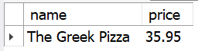

**4. Identify the most common pizza size ordered.**

SELECT

pizzas.size,

COUNT(order_details.order_details_id) AS order_count

FROM

pizzas

JOIN

order_details ON pizzas.pizza_id = order_details.pizza_id

GROUP BY pizzas.size

ORDER BY order_count DESC;

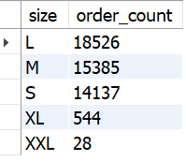

**5. List the top 5 most ordered pizza types along with their quantities**.

SELECT

pizza_types.name, SUM(order_details.quantity) AS quantity

FROM

pizza_types

JOIN

pizzas ON pizza_types.pizza_type_id = pizzas.pizza_type_id

JOIN

order_details ON order_details.pizza_id = pizzas.pizza_id

GROUP BY pizza_types.name

ORDER BY quantity DESC

LIMIT 5;

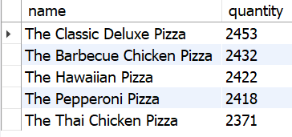

**6. Join the necessary tables to find the total quantity of each pizza category ordered.**

SELECT

pizza_types.category,

SUM(order_details.quantity) AS quantity

FROM

pizza_types

JOIN

pizzas ON pizza_types.pizza_type_id = pizzas.pizza_type_id

JOIN

order_details ON pizzas.pizza_id = order_details.pizza_id

GROUP BY pizza_types.category

ORDER BY quantity DESC;

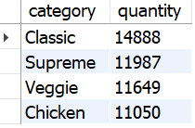

**7. Determine the distribution of orders by hour of the day.**

SELECT

HOUR(order_time) AS hour, COUNT(order_id) AS order_count

FROM

orders

GROUP BY HOUR(order_time);

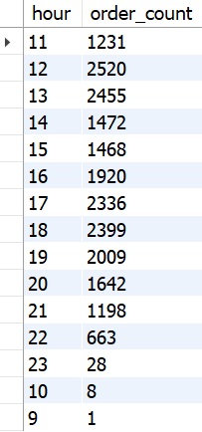

**8. Join relevant tables to find the category-wise distribution of pizzas.**

SELECT

category, COUNT(name)

FROM

pizza_types

GROUP BY category;

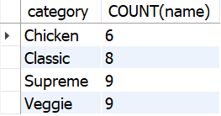

**9. Group the orders by date and calculate the average number of pizzas ordered per day**

SELECT

ROUND(AVG(quantity), 0) as avg_pizza_ordered_per_day

FROM

(SELECT

orders.order_date, SUM(order_details.quantity) AS quantity

FROM

orders

JOIN order_details ON orders.order_id = order_details.order_id

GROUP BY orders.order_date) AS order_quantity;



**10. Determine the top 3 most ordered pizza types based on revenue.**

SELECT

pizza_types.name,

SUM(order_details.quantity * pizzas.price) AS revenue

FROM

pizza_types

JOIN

pizzas ON pizzas.pizza_type_id = pizza_types.pizza_type_id

JOIN

order_details ON order_details.pizza_id = pizzas.pizza_id

GROUP BY pizza_types.name

ORDER BY revenue DESC

LIMIT 3;

**11. Calculate the percentage contribution of each pizza type to total revenue.**

SELECT

pizza_types.category,

ROUND(SUM(order_details.quantity * pizzas.price) / (SELECT

ROUND(SUM(order_details.quantity * pizzas.price),

2) AS total_sales

FROM

order_details

JOIN

pizzas ON pizzas.pizza_id = order_details.pizza_id) * 100,

2) AS revenue

FROM

pizza_types

JOIN

pizzas ON pizza_types.pizza_type_id = pizzas.pizza_type_id

JOIN

order_details ON order_details.pizza_id = pizzas.pizza_id

GROUP BY pizza_types.category

ORDER BY revenue DESC;

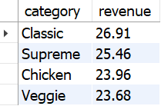

**12. Analyze the cumulative revenue generated over time.**

select order_date,

sum(revenue) over(order by order_date) as cum_revenue

from

(select orders.order_date,

sum(order_details.quantity * pizzas.price) as revenue

from order_details join pizzas

on order_details.pizza_id = pizzas.pizza_id

join orders

on orders.order_id = order_details.order_id

group by orders.order_date) as sales;

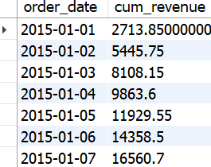

**13. Determine the top 3 most ordered pizza types based on revenue for each pizza category.**

select name, revenue from

(select category, name, revenue,

rank() over(partition by category order by revenue desc) as rn

from

(select pizza_types.category, pizza_types.name,

sum((order_details.quantity) * pizzas.price) as revenue

from pizza_types join pizzas

on pizza_types.pizza_type_id = pizzas.pizza_type_id

join order_details

on order_details.pizza_id = pizzas.pizza_id

group by pizza_types.category, pizza_types.name) as a) as b

where rn<=3;

